- Labelled Diagram of a Typical Home WiFi Router and Network Switch

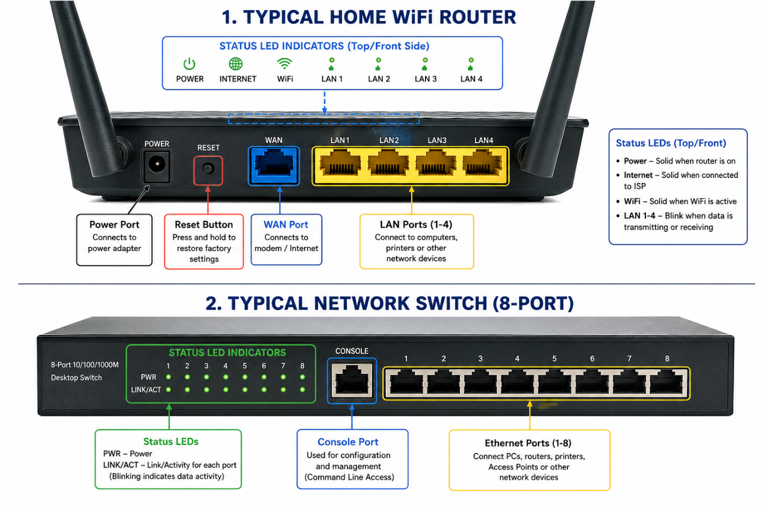

- List 3 Key Differences Between Routers and Switches

Router | Switch
- A router connects different networks, such as a home network to the Internet. | A switch connects devices within the same local network (LAN).
- A router uses IP addresses to send data to the correct network. | A switch uses MAC addresses to send data to the correct device.
- A router forwards data between different networks and can provide Internet access. | A switch forwards data only between devices on the same network and does not provide Internet access by itself.

- Identification of Router and Switch Components

The image below shows a home WiFi router and a network switch. The following parts are identified on both devices:
- Power Port
- WAN Port (Router)
- LAN / Ethernet Ports
- LED Indicators
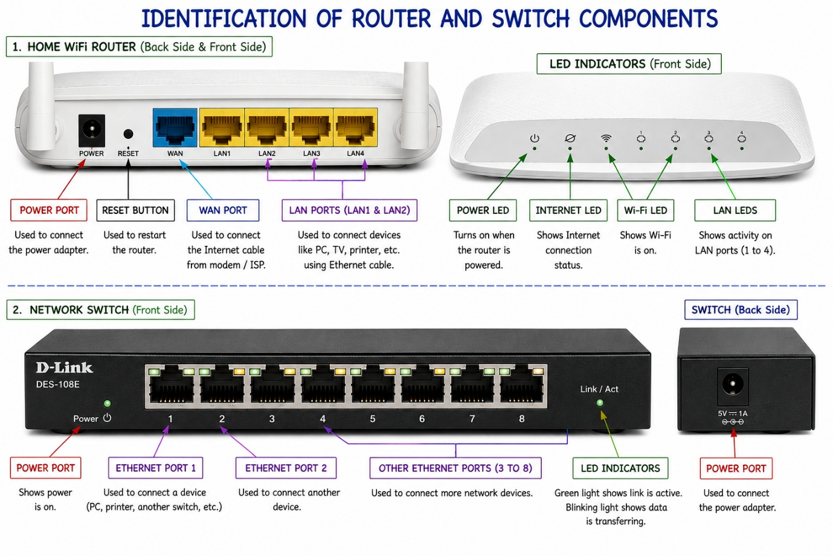

- Small Gaming Café Network Setup

- I am setting up a small gaming café with 8 gaming PCs for online games and IPL streaming.
- First, I will connect the ISP Internet cable to the WAN port of the router. The router will receive the Internet and provide IP addresses to all devices.
- Next, I will connect one LAN port of the router to a network switch using an Ethernet cable.
- Then, I will connect all 8 gaming PCs to the switch using Ethernet cables.

- Connection:
ISP → Router (WAN Port) → Router LAN Port → Switch → 8 Gaming PCs

- Reason for this setup:
The router connects the café to the Internet.
The switch allows all 8 gaming PCs to be connected.
All PCs can use the Internet and play multiplayer games together

